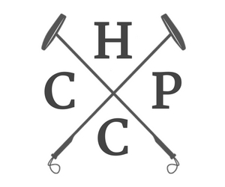
Harvest Cup Polo Classic — Donor Participation Form 2021

Business Name:
(as to be written on marketing materials)
Contact Name: _ Address: _ Email:_____________________________________________Phone/Fax:
Donation Item Description (name of item or name of artwork):

Retail Value of Item:
AUTHORIZED BY:
Date of item delivery or pick up: Do they need power source/equipment? If yes, please describe. _________________________________
In-Kind Donor Levels (Check one if Event or Patron Party tickets are owed based on donation value):
$500 2 Polo tickets
$750 4 Polo tickets
$1500 8 Polo tickets
$3500 8 Polo and 4 Patron Party tickets
$7500 16 Polo and 8 Patron Party tickets

To be filled out by Polo Committee member:
Committee Member Name: Phone:____________________________________ Email:____________________________________________________
Date:
Does donation item(s) qualify donor for complimentary event tickets (see below)? ¨Yes or ¨No

Thank you for your support.
The Junior League of Greater Covington is an organization of women committed to promoting volunteerism, developing the potential of women, and improving the community through the effective action and leadership of trained volunteers. Its purpose is exclusively educational and charitable. Junior League of Greater Covington qualifies as tax exempt under Section 501(c)(3) of the Internal Revenue Code. EIN: 72-0838764

Additional signage and recognition is negotiable for higher level donors.

JLGC advises items over 50 lbs. be delivered to auction winner by the Donor, unless agreed upon before the date of the HCPC event. We love having the item on site but it is not necessary. If the Donor insists on having the item on-site, they are responsible for item delivery.

Jennifer Jeanfreau Krista Eleew
HCPC Chair/VP Fund development Asst. VP Fund Development Silent Auction Chair
HCPC@jlgc.net AVP-fund@jlgc.net Auction@jlgc.net

