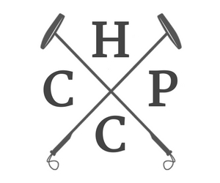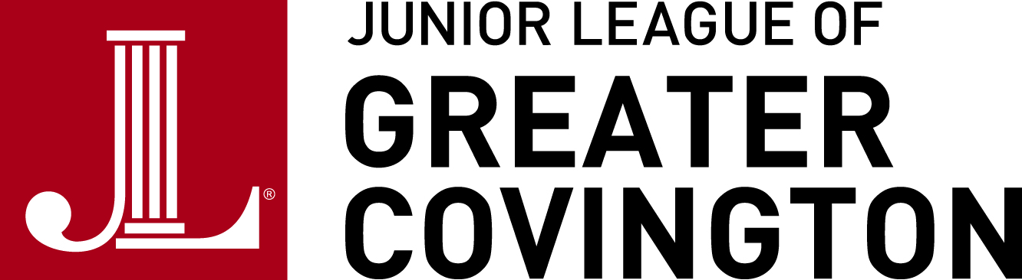

Dear Sponsor -- Thank you for supporting the Junior League of Greater Covington’s Miss Polo With a Purpose Hat Contest! Participants in this contest will be recognized by VIP NorthShore magazine as well as the Greater Covington community at our annual Harvest Cup Polo Classic Tournament, which will be held October 20, 2019 at 10:00 AM at Summergrove Farms in Folsom, LA. By pledging your support, you are supporting the mission of the Junior League in addition to sponsoring YOUR participant in this contest. This contest will include two components: amount of donations received and best polo hat! This contest will be held at our polo event. Thank you so much for your support! May the best hat and most philanthropic candidate win. Good luck! Sincerely, Kayla Tolar, President, on behalf of Junior League of Greater Covington’s Fund Development/ Harvest Cup Polo Classic 2019 Committee

Participant’s Information:
Participant Number Phone Number
First Name E-mail Address
Last Name My Pledge Goal

Sponsor’s Information:
First Name
Last Name
Mailing Address
Donation Amount
Payment Type

Please make checks payable to Junior League of Greater Covington and write the participation number AND full name (first and last) in the “memo” line. All donations are tax deductible. A donation receipt will be mailed and/or e-mailed to each sponsor at the end of the Miss Polo With a Purpose contest (October 20, 2019). Please allow 4-6 weeks for donation receipts to be remitted. Thank you for your support!

(JLGC Use Only)
Date Received by JLGC
Receipt Issued

